AuSSI-SA Education for Sustainability Indicators for Students
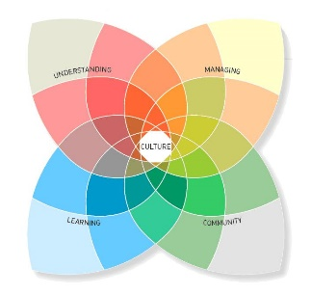
The Australian Sustainable Schools Initiative (AuSSI-SA) is encouraging all schools to become more sustainable. Sustainability means creating a fairer world for all. This involves reducing the use of resources such as energy and water, and improving biodiversity to support native plants and animals. It also means considering the needs of and supporting other people in the world. Your opinion about your school’s efforts to become sustainable and what they should do next is very important. Please complete the statements below to support your school’s progress in sustainability.

School: Name: Year level:

= Agree = Wish it would happen

Starting
- When we talk about our school values, we mention caring for or respecting the environment.
- We are asked what we would like our school environment to be like.
- Different people come to our school to talk about caring for the environment.
- We have looked at what we do well and which environmental behaviours we can to improve.
- We learn about caring for the environment in the classroom.
- We have lots of places in the school and community where we can learn to care for the environment.
- We talk about how we would like our community to develop.
- Students can be leaders in environmental care.

Challenging
- Our school talks about education for sustainability or living more sustainably.
- We want our school to become more sustainable.
- We learn about sustainability concerns and needs in our community.
- We identify sustainability topics and themes we want to take action on.
- Students manage some aspects of the school environment (e.g. recycling).
- Our parents come to school to learn more about living sustainably.
- We use our sustainability interests to take action with other students.
- We have helped to put together a School Environment Management Plan.

Committing
- We learn with people in other parts of Australia and the world how to live more sustainably.
- We are learning to live more sustainably in the classroom, school and community.
- Many of us have a leadership role in sustainability at our school.
- Our reports contain information about our sustainability learning and achievements.
- We share our sustainability learning with other schools and preschools.
- Our school events (like Sports Day) are managed in a sustainable way.
- My family and I want to live more sustainably.
- If we have a good idea for a sustainability action, we can make it happen.

Transforming
- I am living more sustainably at school and in the community.
- I try to influence other people to live more sustainably.
- My family is living more sustainably.
- My family tries to buy local and Fair Trade products.
- I think about being more sustainable when I buy ‘stuff’.
- I know many leaders of sustainability actions in our community
- I support or I am part of groups who are working on sustainability initiatives.

Comments:

